How to Configure Sales Commissions in Odoo 19
Rohan Raj — Infintor Solutions | March 2026

Introduction
Sales commissions in Odoo 19 allow businesses to automate incentive calculations for their sales teams. Instead of tracking targets and payouts manually in spreadsheets, the Commissions module handles achievement tracking, tiered payouts, and payroll integration directly within the Sales app.
This guide covers how to enable commissions, create commission plans, configure targets and achievements, and generate commission reports in Odoo 19.

Enabling the Commissions Module
Go to Sales → Configuration → Settings. Under the Invoicing section, enable the Commissions checkbox and click Save.
Once enabled, a new Commissions menu appears under the Sales app with three sub-menus:
- Commission Plans — create and manage commission plans
- Commissions — view calculated commission data for all salespeople
- My Commissions — view commission data for the logged-in user only
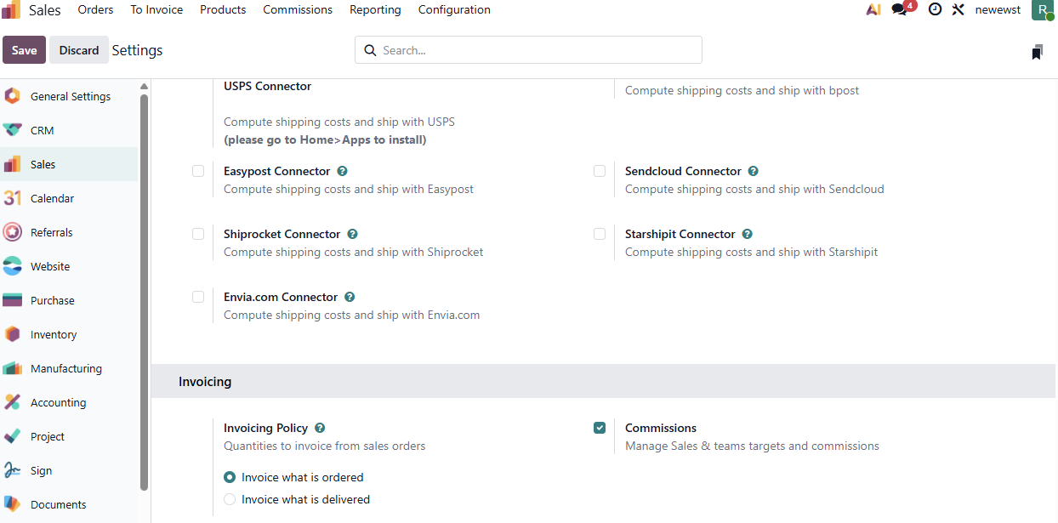
Sales Settings with Commissions enabled

Creating a Commission Plan
Sales → Commissions → Commission Plans → New
Fill in the following fields:
- Name — a descriptive label for the plan
- Based on — select Targets (goal-based with tiers) or Achievements (flat rate on actuals)
- per — choose Salesperson (individual tracking) or Sales Team (collective tracking)
- On Target Commission — the payout amount at 100% target achievement
- Effective Period — the plan’s start and end dates
- Target Frequency — how often targets reset: Monthly, Quarterly, or Yearly
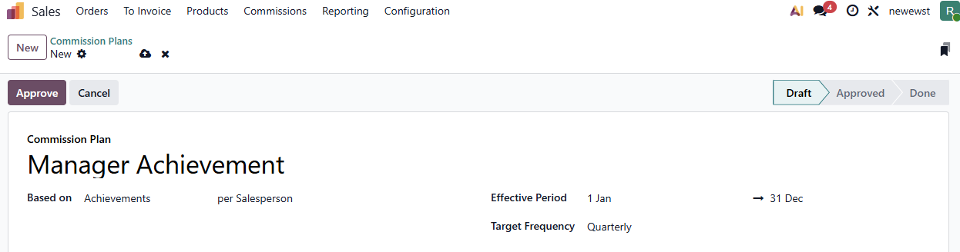
Commission Plan form with header fields

Target-Based vs Achievement-Based Plans

Feature | Target-Based | Achievement-Based
How it works | Set a sales goal per period; payout based on % achieved | Flat commission rate on actual performance
Commission Levels (tiers) | Yes — define payouts at 0%, 50%, 100%, 150% | No — single flat rate
Best for | Quarterly/yearly goals with escalating incentives | Ongoing, consistent commission structures
Target amounts required | Yes | No

Setting Up Targets
For target-based plans, Odoo auto-generates periods based on the selected target frequency. Each period includes a target amount that you can edit individually.

Setting Up Achievements
Go to the Achievements tab and configure:
- Type — Amount Invoiced, Amount Sold, Quantity Invoiced, or Quantity Sold
- Rate — multiplier applied to the achievement (default: 1.0)
- Category — optional product category filter to commission only specific products
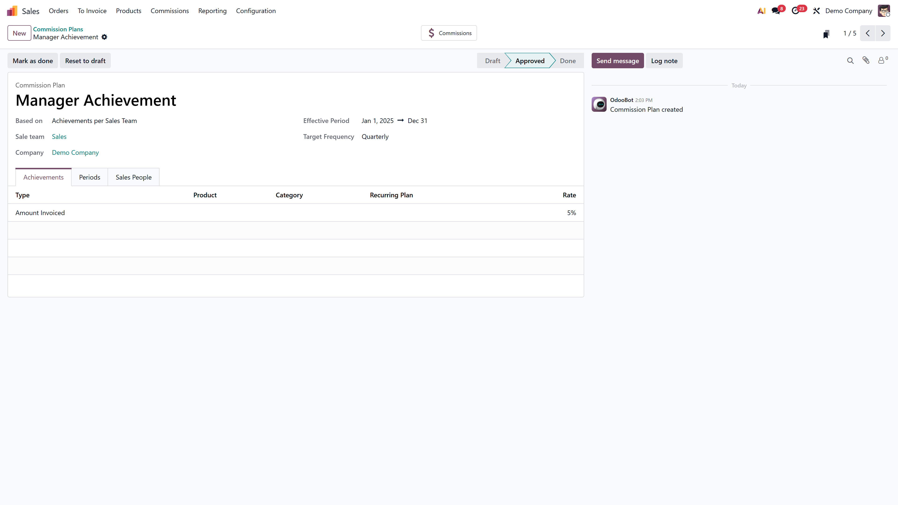
Achievements tab with Type set to Amount Invoiced

Assigning Salespeople
In the Sales People tab, add the salespeople who will be tracked under this plan. Each entry allows:
- Custom From and To dates for mid-period additions or removals
- Individual tracking within individual plans or team-level tracking within team plans

Commission Levels
For target-based plans, the Commission Levels tab lets you define tiered payouts:
- 0% of target → ₹0
- 50% of target → ₹10,000
- 100% of target → ₹30,000
- 150% of target → ₹45,000
Odoo interpolates linearly between levels.
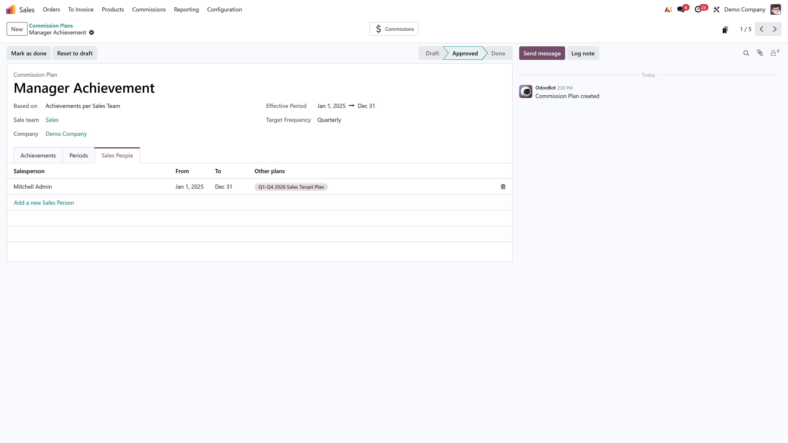
Commission levels showing tiered payout structure

Adjustments
Go to the Adjustments tab to make manual corrections. Each adjustment records:
- Achieved amount — the correction value
- Add User — salesperson whose commission increases
- Reduce User — salesperson whose commission decreases (optional)
- Date and Note for audit trail

Approving the Plan
Click Approve to activate the plan. Once approved, Odoo begins tracking sales and calculating commissions automatically. To make changes later, the plan must be Reset to Draft first.

Payroll Integration
With the HR Payroll module installed, each plan gets a Payslip Input field. Link it to a payroll input type (e.g., “Sales Commission”) so that calculated commissions appear automatically in employee payslips.

Viewing Commission Reports
Go to Sales → Reporting → Commissions to view commission data in list, pivot, or graph format. Filter by salesperson, plan, or date range. Each salesperson can also view their own data through the My Commissions menu.
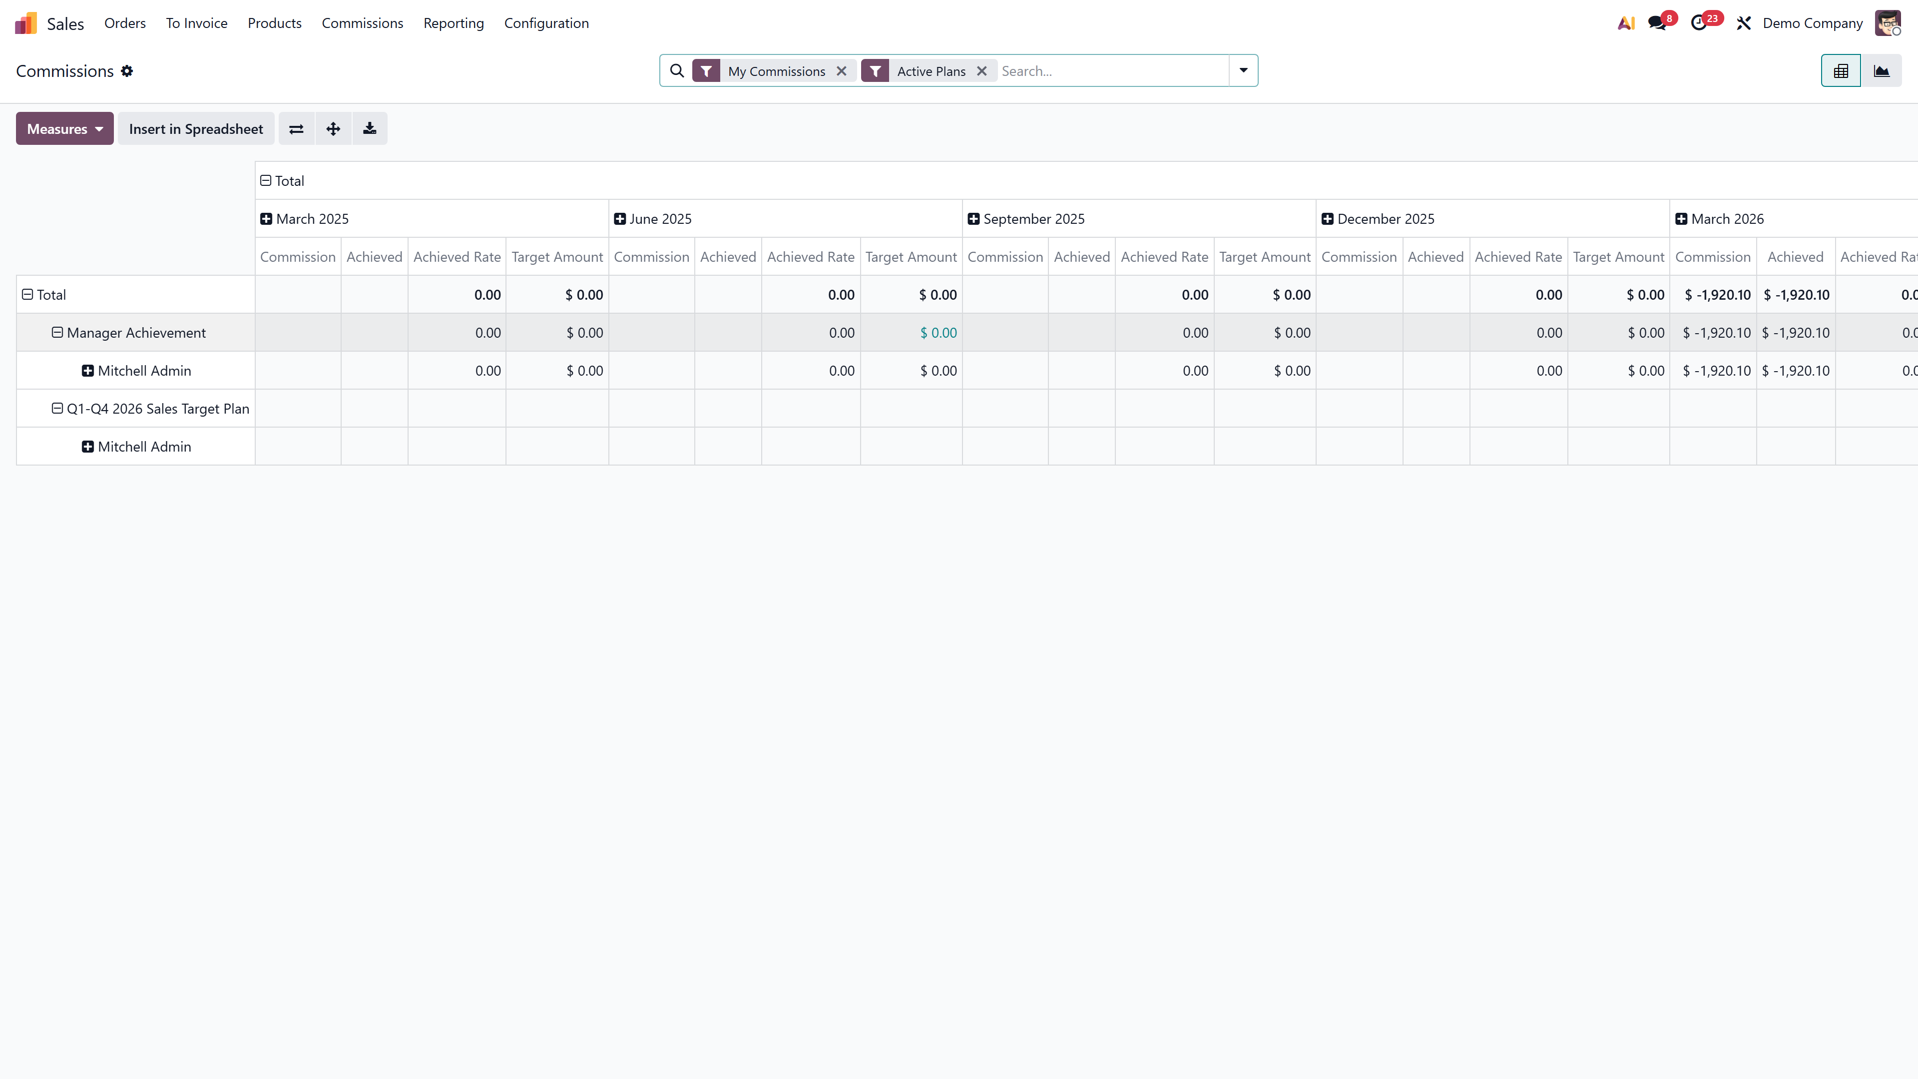
Commission reporting pivot view with per-salesperson breakdown

FAQs
1. Can a salesperson have multiple active commission plans?
Yes. Plans track independently. A salesperson can be part of both a target-based and an achievement-based plan at the same time.
2. What happens when a salesperson joins mid-quarter?
Use the custom From date in the Sales People tab. The salesperson will only be evaluated from that date onward.
3. Can I commission on specific product categories only?
Yes. Set the Category field on the achievement line to filter by product category.

Automate your sales commission process with Odoo 19. Connect with us at infintor.com for expert guidance.

